Sist 2019

05-08 November 2019 - Toulouse

**How to create a DOI with the**

**cataloging tool Geonetwork**

Annick Battais

**Why would you choose Geonetwork?**

* Platform IDS: OSURIS [https://accueil.osuris.fr](https://translate.google.com/translate?hl=en&prev=_t&sl=sv&tl=en&u=https://accueil.osuris.fr/). Geonetwork is the tool for cataloging and accessing metadata and data of l'OSUR (l’Observatoire des Sciences de l’Univers de Rennes)
* Gather all the information of a metadata in one go tool
* Reference of the landing pages of the DOIs points to the sheets of Geonetwork metadata
* Wished to support a tool we knew
* Strong request from users to create DOIs

**Possible DOI creation tools**

* From the interface <https://doi.test.datacite.org>
* Online form
* Upload (xml format)
* From Geonetwork 3.6 via the DataCite API

**Configuration in geonetwork**

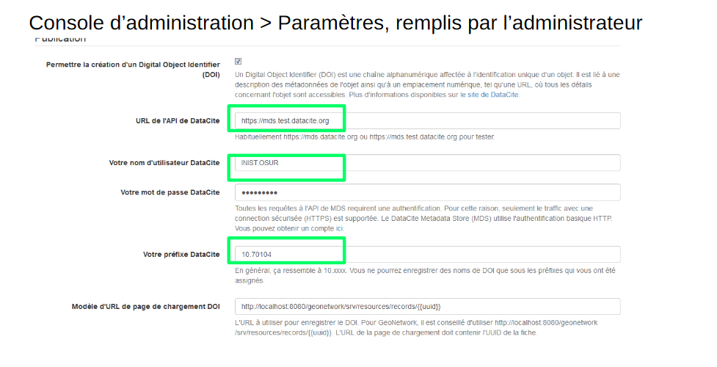**How to create a DOI**

* Requires ‘administrator’ privileges
* enable DOI creation in the ‘settings’ (see above)
* for each record:
  + select ‘manage record’
  + ensure record is ‘published’
  + click ‘DOI request’

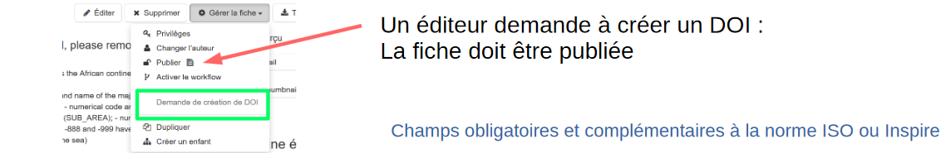

|  |  |
| --- | --- |
| **Mandatory, recommended and optional fields to conform to ISO or Inspire** | |
|  | * Doi field ==> constructed from the uuid   eg: DOI: 10.70104 / da165110-88fd-11da-a88f-000d939bc5d8●   * Creator field: point of contact (simple view) * Title (simple view) * Publisher: onglet distribution - specify the name of the organization and the role of "publisher", (complete view) * Publisher year (simple view) * Resource type general (simple view; eg: dataset, collection ...) |
|  |  |

**Fields generated by the API**

* Identifier: uuid
* State: three possible states
  + Draft: the DOI can be removed
  + Registered: registered but not indexed
  + Findable: indexed
    - Draft ==> (registered, findable)
    - Registered <==> Findable
  + By default, the DOI is created in the searchable state.
* Url: link to landing page (link to metadata in Geonetwork)



**Workflow for the request**

* 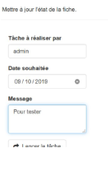The reviewer of the group (user administrator) or the administrator is alerted to the creation request by a message.
* Prerequisite verification (via the administration / statistics console and a statute / version)
* Create a DOI: the line appears in the GN metadata file
* The DOI appears on the MDS DataCite website

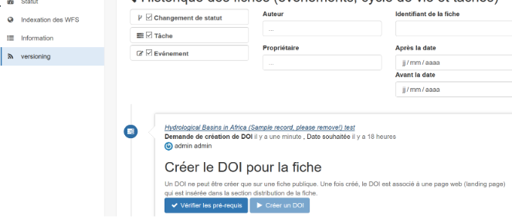

**Possible error messages**

* 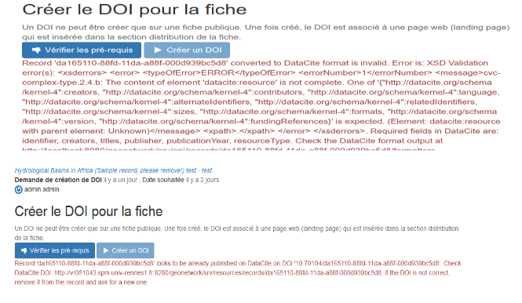Format problem
* DOI already exists
* To debug:

<http://vr051043.spm.univ-rennes1.fr:8280/geonetwork/srv/api/records/>

da165110-88fd-11da-a88f-000d939bc5d8 / formatters / datacite? Output = xml

**Necessary Conditions**

To be able to put a DOI on a metadata, it is necessary:

* not a template
* not a matter of a moon
* wants to be published
* configured with login, mdp in GN
* does not already exist
* mandatory fields are all present

**Conclusions**

Tests to be performed by the SGDN (Numerical Data Management Service) of the OSUR

* The metadata is by default found in the state, it is not possible to modify a draft or delete the DOI.
  + ● modify catalog / views / defaults / directives / directive.js?
* How to update the metadata? (versions, adding a keyword),
  + ● routine to implement?
* Understand the roles and rights of each,
* Identify GN error messages and identify solutions
* Integrate the required and optional mandatory fields for a DOI into a template

**References**

- [https://support.datacite.org/docs/mds-api-guide](https://translate.google.com/translate?hl=en&prev=_t&sl=sv&tl=en&u=https://support.datacite.org/docs/mds-api-guide)

- [https://www.geonetwork-opensource.org/manuals/3.8.x/fr/user-guide/associating-resources/doi.html](https://translate.google.com/translate?hl=en&prev=_t&sl=sv&tl=en&u=https://www.geonetwork-opensource.org/manuals/3.8.x/fr/user-guide/associating-resources/doi.html)

- [https://github.com/geonetwork/core-geonetwork/pull/3281/](https://translate.google.com/translate?hl=en&prev=_t&sl=sv&tl=en&u=https://github.com/geonetwork/core-geonetwork/pull/3281/)

- [https://www.ifremer.fr/sextant_doc/sextant/sextant/doi/DOI_dans_metadonnee.pdf](https://translate.google.com/translate?hl=en&prev=_t&sl=sv&tl=en&u=https://www.ifremer.fr/sextant_doc/sextant/sextant/doi/DOI_dans_metadonnee.pdf)